MOMENTUM MULTIPLY
"UNLOCK YOUR FUTURE SELF" CAMPAIGN
LANDING PAGE / MINI WEBSITE DEVELOPER BRIEF

PROJECT OVERVIEW
Campaign Name
Unlock Your Future Self
Client
Momentum Multiply (Leré Smith)
Project Type
Interactive Campaign Landing Page / Mini Website
Project Objective
The landing page serves as the central digital hub for the Momentum Multiply "Unlock Your Future Self" campaign, launched around the Mind Matters Summit 2026.
The platform should inspire visitors to actively engage with their future wellbeing journey through a series of immersive experiences, challenges, competitions, content pieces, and educational resources.
The website must create a sense of curiosity, anticipation, and personal transformation while reinforcing how small daily actions can contribute to a better future self.
The site should showcase the five Multiply pillars throughout the user journey:
- Eat
- Sleep
- Move
- Breathe
- Connect
These pillars should be woven into the content architecture and user experience rather than appearing as isolated sections.

STRATEGIC CAMPAIGN NARRATIVE
Core Thought
The future version of yourself is not created overnight.
It is built through the small decisions you make every day.
Every healthy meal.
Every walk.
Every good night's sleep.
Every meaningful connection.
Every mindful moment.
Momentum Multiply rewards and supports these positive behaviours.
The campaign encourages people to imagine their future self and then take practical steps toward becoming that person.

PRIMARY WEBSITE OBJECTIVES
The landing page should:
- Introduce the campaign narrative.
- Showcase all campaign experiences.
- Capture competition entries.
- Drive engagement with Multiply activities.
- Educate users around the five pillars.
- House campaign content and future updates.
- Create excitement leading up to and following the Mind Matters Summit.
- Provide a platform that can grow throughout the campaign lifecycle.

TARGET AUDIENCE
Primary Audience:
- Existing Momentum Multiply members
- Momentum members not yet actively engaging with Multiply
- Mind Matters Summit attendees
- Media and influencers
- Health-conscious professionals
Secondary Audience:
- General public interested in personal growth and wellbeing
- Future Momentum customers

WEBSITE EXPERIENCE
The website should feel:
- Aspirational
- Premium
- Modern
- Personal
- Interactive
- Human
- Emotionally engaging
The experience should make users feel:
“I can unlock my full potential”

BRANDING REQUIREMENTS
The site must align with Momentum Multiply brand guidelines.
Use:
- Momentum Multiply brand colours
- Momentum Multiply visual language
- Existing brand typography
- Existing brand imagery style
Visual direction should focus on:
- Growth
- Progress
- Transformation
- Possibility
- Future-focused thinking
Avoid:
- Clinical healthcare styling
- Fear-based messaging
- Overly corporate language

WEBSITE STRUCTURE
SECTION 1
HERO SECTION
Headline:
Unlock Your Future Self
Supporting Copy:
Every choice you make today shapes the person you become tomorrow.
CTA:
Unlock Your Journey
Secondary CTA:
Unlock Experiences
Possible visual treatments:
- Future-focused imagery
- Animated growth elements
- Dynamic motion graphics
- Human-centred lifestyle visuals

SECTION 2
CAMPAIGN INTRODUCTION
Purpose:
Explain the campaign concept.
Content should answer:
- What is Unlock Your Future Self?
- Why was it created?
- How can users participate?
Suggested flow:
Who you are tomorrow starts with what you do today.
Momentum Multiply rewards positive everyday actions that help you become your healthiest, happiest and most fulfilled self.
Throughout this campaign, you'll discover experiences, challenges and opportunities designed to help you unlock your future self.

SECTION 3
THE FIVE PILLARS
Interactive section introducing:
- Eat
- Sleep
- Move
- Breathe
- Connect
Each pillar should have:
- Icon
- Short description
- Expandable content
- Associated rewards information
Potential functionality:
Hover cards, accordions or interactive tiles.

ACTIVATIONS HUB
This section acts as the main campaign navigation area.
Each activation should have:
- Thumbnail image
- Brief explanation
- CTA
- Status indicator
Examples:
Live Now
Coming Soon
Completed

ACTIVATION SUMMARIES
1. FUTURE SELF LETTER
Summary
Users are invited to write a letter from their future self to the person they are today.
The exercise encourages reflection, goal setting and positive future thinking.
Website Requirements
Dedicated activation page containing:
- Introduction
- Instructions
- Writing prompts
- Submission form
- Thank you page
Optional functionality:
- Schedule letter delivery by email at a future date
- Download PDF copy

2. THE FUTURE CALL
Summary
A cinematic experience where users receive a motivational phone call from their future self.
The future self shares wisdom, encouragement and insights from the life they are currently building.
Website Requirements
Dedicated activation page containing:
- Intro copy
- Video player
- Audio playback capability
- Sharing functionality
Future enhancement:
Personalised versions based on user inputs.

3. THE BLUEPRINT OF YOU
Summary
An interactive self-discovery experience that helps participants identify the habits, behaviours and choices shaping their future.
Users receive a personalised blueprint highlighting areas of growth.
Website Requirements
- Interactive questionnaire
- Multi-step form
- Results page
- Shareable outcome
Potential future integration:
Personalised recommendations based on Multiply pillars.

4. PRESCRIPTION FOR YOUR FUTURE SELF
Summary
A personalised wellbeing recommendation engine.
Participants answer a short series of questions and receive practical actions aligned to the five Multiply pillars.
Website Requirements
- Assessment flow
- Dynamic recommendations
- Personalised results page
- Downloadable action plan

5. THE NEXT SELF WALL
Summary
A digital wall showcasing commitments, aspirations and future goals submitted by participants.
The wall represents collective growth and positive change.
Website Requirements
- Submission functionality
- Moderation capability
- Search functionality
- Dynamic content feed
Display formats:
- Digital sticky notes
- Interactive cards
- Future goals mosaic

6. UNLOCKED PODCAST SERIES
Summary
A podcast series exploring personal growth, wellbeing and the practical actions that shape our future selves.
Episodes feature experts, thought leaders and inspiring stories.
Website Requirements
Status:
Coming Soon
Functionality:
- Podcast landing page
- Episode library
- Audio player
- Episode summaries
- Guest profiles
Future scalability required.

COMPETITION SECTION
Purpose:
Drive participation across campaign activities.
Requirements
Dedicated competition area including:
- Competition explanation
- How to enter
- Terms and conditions
- Entry tracking information
Potential mechanic:
Participants earn entries through engagement with campaign experiences.

USER ACCOUNT / DATA REQUIREMENTS
If permitted by Momentum systems:
Data capture:
- First name
- Last name
- Email address
- Mobile number
- Member status
All forms must:
- Include consent checkboxes
- Comply with POPIA requirements
- Include privacy policy links

CONTENT MANAGEMENT REQUIREMENTS
The website should be easily updated by the internal team.
Recommended CMS capabilities:
- Add new activations
- Update copy
- Upload images
- Add podcast episodes
- Publish blog articles
- Update competition details
Minimal developer involvement should be required after launch.

ANALYTICS REQUIREMENTS
Track:
- Visits
- Unique users
- Form submissions
- Activation participation
- Competition entries
- Video views
- Podcast plays
- CTA clicks
Preferred integration:
- Google Analytics
- Tag Manager
- Campaign tracking parameters

RESPONSIVE REQUIREMENTS
Must be fully optimised for:
- Mobile
- Tablet
- Desktop
Mobile experience should be prioritised.

PERFORMANCE REQUIREMENTS
Page load targets:
- Fast loading
- Optimised imagery
- Mobile-first performance
Users should experience minimal friction throughout the journey.

PHASED ROLLOUT
PHASE 1
Launch June 2026
Includes:
- Landing page (includes a short video from Saray Khumalo)
- Campaign overview
- Five pillars
- Future Self Letter
- Future Call
- Blueprint of You
- Competition section

PHASE 2
Post-launch enhancements
Includes:
- Prescription for Your Future Self (Dischem)
- Future Self Wall (Imagery)
- Unlocked Podcast Series
- Additional content modules

SUCCESS MEASUREMENT
The website will be considered successful if it:
- Drives meaningful engagement
- Increases participation in campaign experiences
- Encourages interaction with the five pillars
- Generates competition entries
- Creates an emotional connection with the future-self concept
- Positions Multiply as a partner in long-term wellbeing and personal growth

KEY TIMELINES
Development Start:
Immediate
Content Population:
Ongoing
Testing:
Prior to launch
Launch Ready Date:
19 June 2026
Campaign Goes Live:
22 June 2026
Future Enhancements:
Phase 2 rollout following launch

FINAL DEVELOPER NOTE
This is not simply a campaign microsite.
It is a digital journey that helps users envision, engage with and actively build a better future version of themselves.
Every page, interaction and user flow should reinforce one central message:
"The future you is created by what you do today."
Please scroll down to see a visual of the concept to assist with the brief, please note that this is just a mock-up

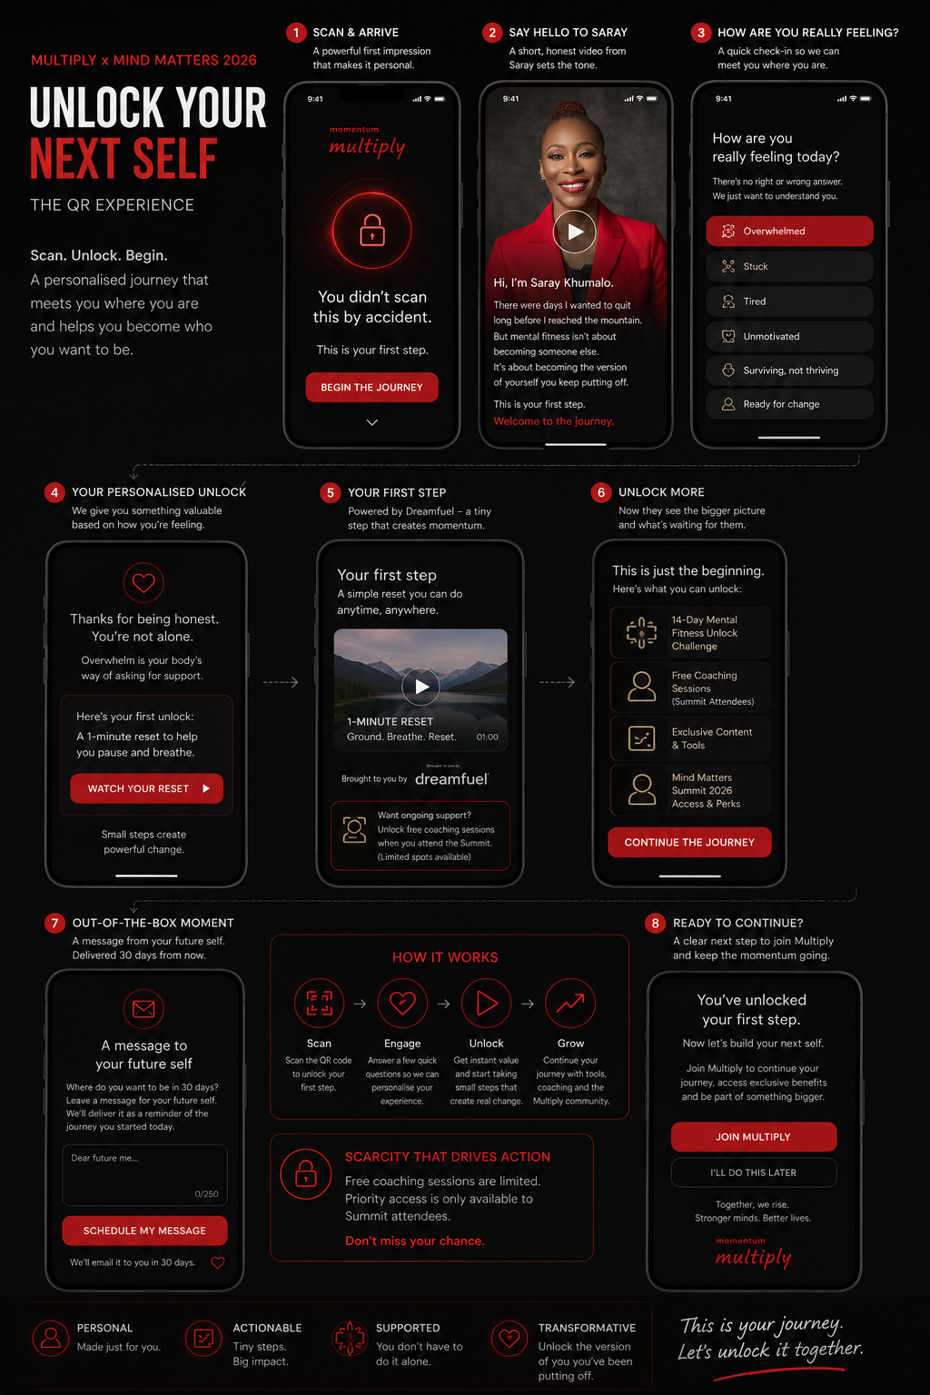
Proposed Architectural Diagram (AWS based)
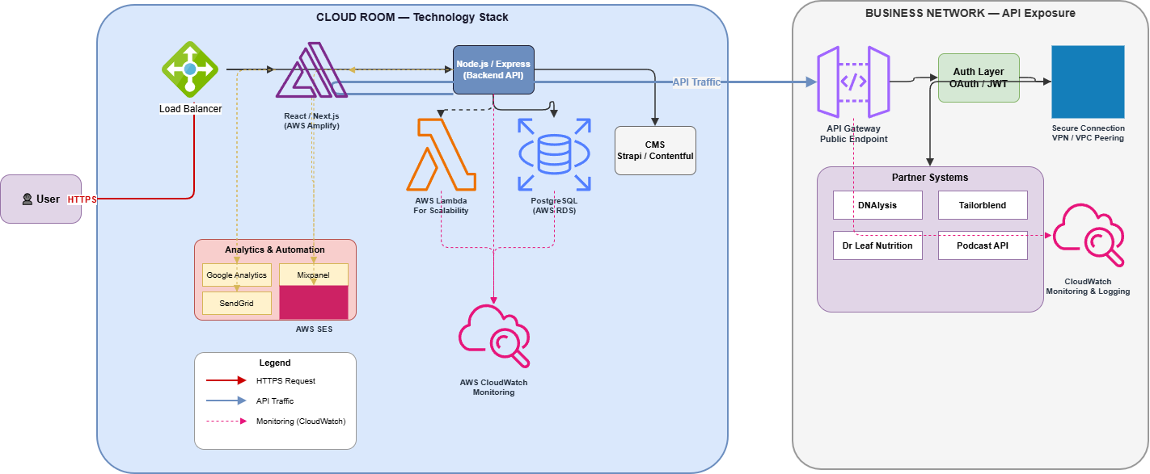

Diagram Summary:

- User traffic enters through a Load Balancer via HTTPS, ensuring reliable distribution.
- Inside the Cloud Room (Technology Stack), the React/Next.js frontend connects to a Node.js/Express backend, supported by AWS Lambda for scalability.
- Data is managed in PostgreSQL (AWS RDS), while Strapi/Contentful CMS handles content.
- Analytics & Automation tools (Google Analytics, Mixpanel, SendGrid, AWS SES) track engagement and trigger workflows.
- AWS CloudWatch provides monitoring across all services.
- On the Business Network side, APIs are exposed through API Gateway, secured by OAuth/JWT authentication and VPN/VPC peering.
- Partner systems — DNAlysis, Tailorblend, Dr Leaf Nutrition, and Podcast API — integrate with centralized monitoring and logging via CloudWatch

AWS Technology Stack Summary:
- Frontend Layer → React / Next.js hosted on AWS Amplify / Vercel for mobile‑first UI and responsive delivery.
- Backend Layer → Node.js / Express providing API logic, routing, and partner integrations.
- Compute Layer → AWS Lambda (labeled “For Scalability”) enabling elastic, serverless execution of workloads.
- Database Layer → PostgreSQL (AWS RDS) for structured campaign and user profile data.
- Content Management → Strapi / Contentful powering dynamic content delivery and campaign phases.
- Analytics & Automation → Google Analytics, Mixpanel, SendGrid, and AWS SES for engagement tracking and automated communication.
- Monitoring & Logging → AWS CloudWatch providing observability, metrics, and centralized logging across services.
- API Exposure (Business Network) → API Gateway with OAuth / JWT authentication, secured via VPN / VPC Peering, integrating with partner systems (DNAlysis, Tailorblend, Dr Leaf Nutrition, Podcast API).

